Fixing the white flickering screen:

GPU information

nvidia-smi
nvtop

lxrandr
lower the refresh rate

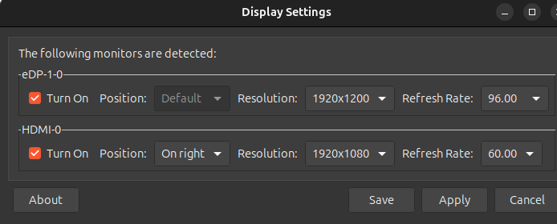
POP OS shell on Ubuntu

https://support.system76.com/articles/pop-shell/

